Superset ID: 6430920

Candidate Name: SUCHITHRA M S

**WEEK 1 HANDS-ON EXERCISE (JAVA FSE DEEPSKILLING)**  
**(PL/SQL Programming)**

**Exercise 1: Control Structures**

**Scenario 1: The bank wants to apply a discount to loan interest rates for customers above 60 years old.**

**Question:** Write a PL/SQL block that loops through all customers, checks their age, and if they are above 60, apply a 1% discount to their current loan interest rates.

-- Customers table

CREATE TABLE Customers (

customer_id NUMBER PRIMARY KEY,

name VARCHAR2(100),

age NUMBER,

balance NUMBER,

isvip VARCHAR2(5)

);

-- Loans table

CREATE TABLE Loans (

loan_id NUMBER PRIMARY KEY,

customer_id NUMBER,

due_date DATE,

interest_rate NUMBER,

FOREIGN KEY (customer_id) REFERENCES Customers(customer_id)

);

-- Inserting sample customers

INSERT INTO Customers VALUES (1, 'Rahul', 65, 12000, 'FALSE');

INSERT INTO Customers VALUES (2, 'Priya', 45, 8000, 'FALSE');

INSERT INTO Customers VALUES (3, 'Amit', 70, 10500, 'FALSE');

INSERT INTO Customers VALUES (4, 'Sneha', 30, 20000, 'FALSE');

-- Inserting sample loans

INSERT INTO Loans VALUES (101, 1, SYSDATE + 10, 8.5);

INSERT INTO Loans VALUES (102, 2, SYSDATE + 35, 9.0);

INSERT INTO Loans VALUES (103, 3, SYSDATE + 5, 7.8);

INSERT INTO Loans VALUES (104, 4, SYSDATE + 25, 8.0);

COMMIT;

DECLARE

CURSOR cur_senior_customers IS

SELECT loan_id, interest_rate

FROM Loans l

JOIN Customers c ON l.customer_id = c.customer_id

WHERE c.age > 60;

v_loan_id Loans.loan_id%TYPE;

v_rate_before Loans.interest_rate%TYPE;

BEGIN

OPEN cur_senior_customers;

LOOP

FETCH cur_senior_customers INTO v_loan_id, v_rate_before;

EXIT WHEN cur_senior_customers%NOTFOUND;

UPDATE Loans

SET interest_rate = v_rate_before - 1

WHERE loan_id = v_loan_id;

END LOOP;

CLOSE cur_senior_customers;

DBMS_OUTPUT.PUT_LINE('Discount applied to interest rates for senior customers.');

EXCEPTION

WHEN OTHERS THEN

DBMS_OUTPUT.PUT_LINE('Error in Senior Discount Block: ' || SQLERRM);

END;

/

**OUTPUT:**

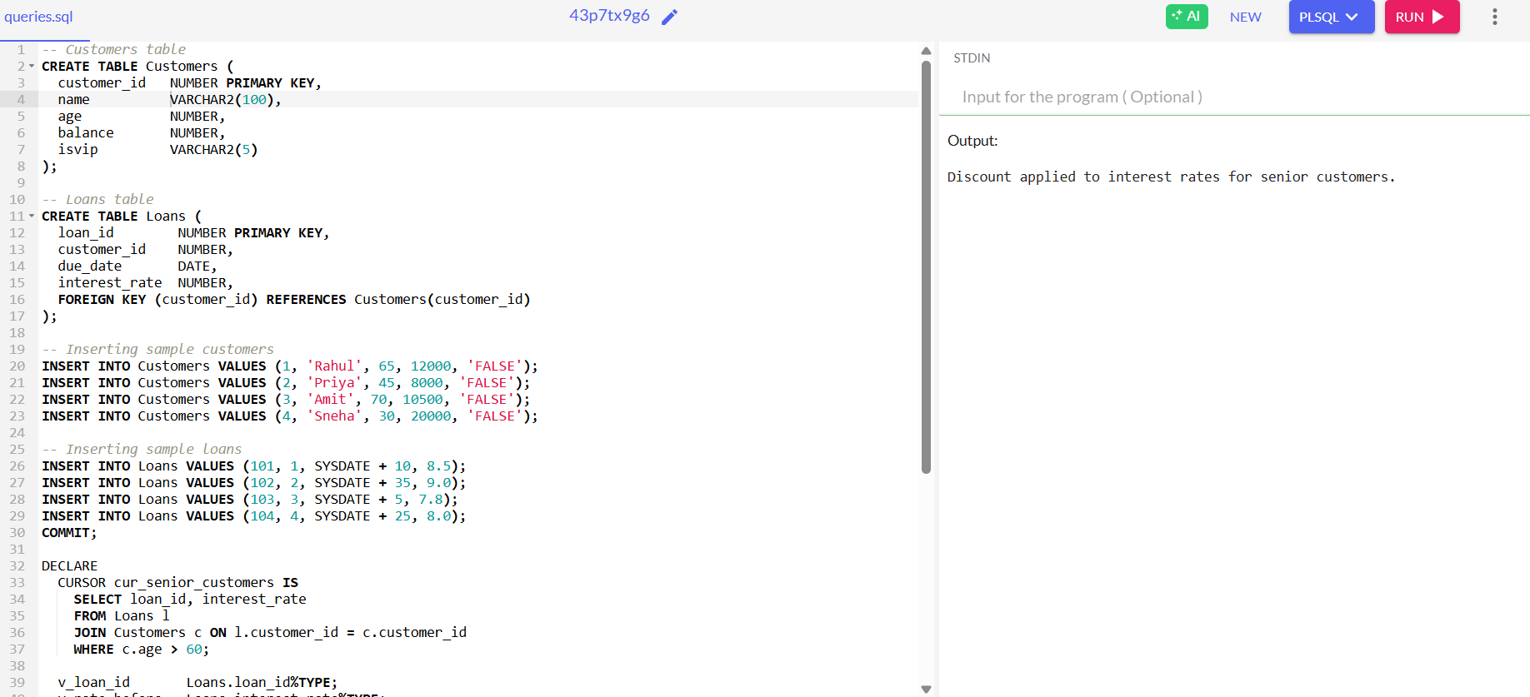

**Scenario 2: A customer can be promoted to VIP status based on their balance.**

**Question:** Write a PL/SQL block that iterates through all customers and sets a flag IsVIP to TRUE for those with a balance over $10,000.

DECLARE

CURSOR vip_eligible_customers IS

SELECT customer_id

FROM Customers

WHERE balance > 10000;

vip_id Customers.customer_id%TYPE;

BEGIN

OPEN vip_eligible_customers;

LOOP

FETCH vip_eligible_customers INTO vip_id;

EXIT WHEN vip_eligible_customers%NOTFOUND;

UPDATE Customers

SET isvip = 'TRUE'

WHERE customer_id = vip_id;

END LOOP;

CLOSE vip_eligible_customers;

DBMS_OUTPUT.PUT_LINE('VIP status updated for customers with balance above 10,000.');

EXCEPTION

WHEN OTHERS THEN

DBMS_OUTPUT.PUT_LINE('Error in Scenario 2: ' || SQLERRM);

END;

/

**OUTPUT:**

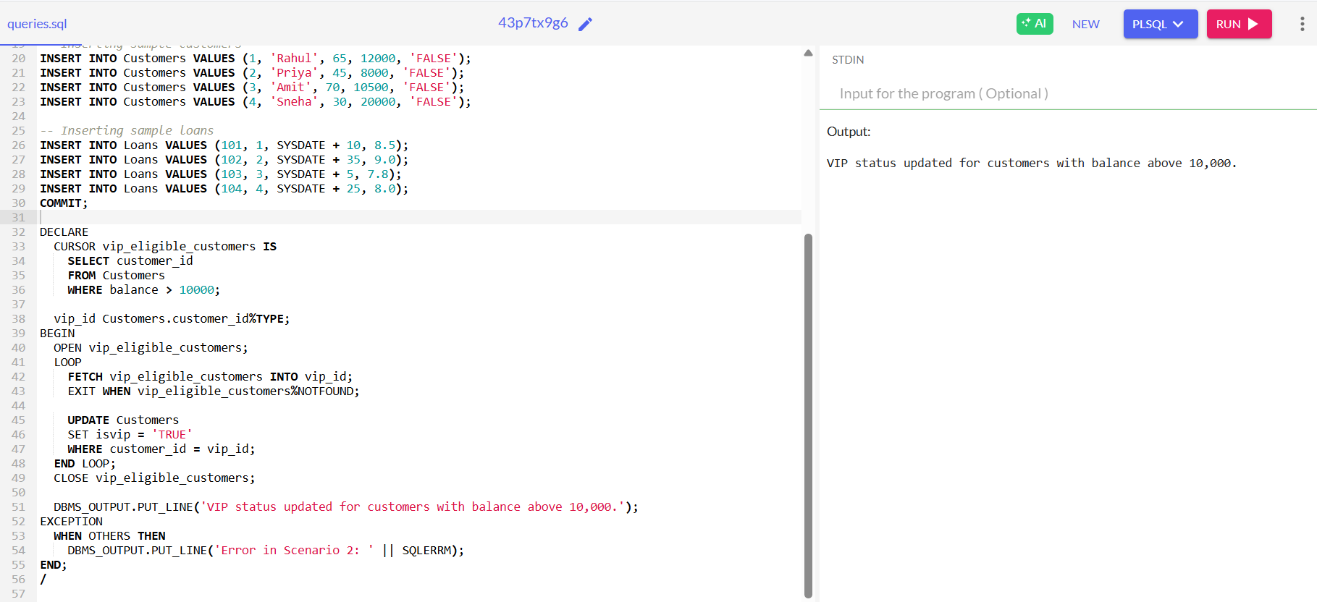

**Scenario 3: The bank wants to send reminders to customers whose loans are due within the next 30 days.**

**Question:** Write a PL/SQL block that fetches all loans due in the next 30 days and prints a reminder message for each customer.

DECLARE

CURSOR due_soon_loans IS

SELECT c.name, l.due_date

FROM Customers c, Loans l

WHERE c.customer_id = l.customer_id

AND l.due_date BETWEEN SYSDATE AND SYSDATE + 30;

cust_name Customers.name%TYPE;

due_date_value Loans.due_date%TYPE;

BEGIN

OPEN due_soon_loans;

LOOP

FETCH due_soon_loans INTO cust_name, due_date_value;

EXIT WHEN due_soon_loans%NOTFOUND;

DBMS_OUTPUT.PUT_LINE('Reminder: ' || cust_name || ', your loan is due on ' || TO_CHAR(due_date_value, 'DD-MON-YYYY'));

END LOOP;

CLOSE due_soon_loans;

DBMS_OUTPUT.PUT_LINE('Loan reminders printed for upcoming due dates.');

EXCEPTION

WHEN OTHERS THEN

DBMS_OUTPUT.PUT_LINE('Error in Scenario 3: ' || SQLERRM);

END;

/

**OUTPUT:**

**Exercise 3: Stored Procedures**

**Scenario 1: The bank needs to process monthly interest for all savings accounts.**

**Question:** Write a stored procedure ProcessMonthlyInterest that calculates and updates the balance of all savings accounts by applying an interest rate of 1% to the current balance.

-- Enable output

SET SERVEROUTPUT ON;

-- Create table if not already created

CREATE TABLE Accounts (

account_id NUMBER PRIMARY KEY,

customer_id NUMBER,

account_type VARCHAR2(20),

balance NUMBER

);

-- Insert sample data

INSERT INTO Accounts VALUES (101, 1, 'Savings', 10000);

INSERT INTO Accounts VALUES (102, 2, 'Current', 15000);

INSERT INTO Accounts VALUES (103, 3, 'Savings', 5000);

COMMIT;

-- Create the procedure

CREATE OR REPLACE PROCEDURE ProcessMonthlyInterest AS

CURSOR savings_cursor IS

SELECT account_id, balance

FROM Accounts

WHERE account_type = 'Savings';

v_account_id Accounts.account_id%TYPE;

v_balance Accounts.balance%TYPE;

v_interest NUMBER;

BEGIN

OPEN savings_cursor;

LOOP

FETCH savings_cursor INTO v_account_id, v_balance;

EXIT WHEN savings_cursor%NOTFOUND;

v_interest := v_balance * 0.01;

UPDATE Accounts

SET balance = balance + v_interest

WHERE account_id = v_account_id;

END LOOP;

CLOSE savings_cursor;

DBMS_OUTPUT.PUT_LINE('Monthly interest applied to savings accounts.');

EXCEPTION

WHEN OTHERS THEN

DBMS_OUTPUT.PUT_LINE('Error during interest processing: ' || SQLERRM);

END;

/

-- Execute the procedure

BEGIN

ProcessMonthlyInterest;

END;

/

**OUTPUT:**

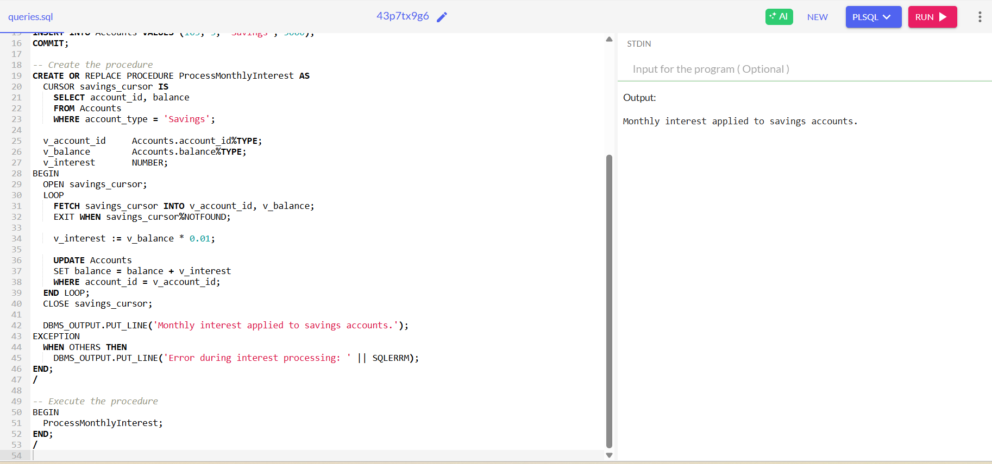

**Scenario 2: The bank wants to implement a bonus scheme for employees based on their performance.**

**Question:** Write a stored procedure UpdateEmployeeBonus that updates the salary of employees in a given department by adding a bonus percentage passed as a parameter.

-- Enable output

SET SERVEROUTPUT ON;

-- Create Employees table (if not exists)

CREATE TABLE Employees (

emp_id NUMBER PRIMARY KEY,

emp_name VARCHAR2(100),

department VARCHAR2(50),

salary NUMBER

);

-- Sample data

INSERT INTO Employees VALUES (1, 'Ravi', 'Sales', 40000);

INSERT INTO Employees VALUES (2, 'Anita', 'Sales', 45000);

INSERT INTO Employees VALUES (3, 'John', 'HR', 30000);

COMMIT;

-- Procedure to update salary with bonus

CREATE OR REPLACE PROCEDURE UpdateEmployeeBonus (

dept_name IN VARCHAR2,

bonus_pct IN NUMBER

) AS

BEGIN

UPDATE Employees

SET salary = salary + (salary * bonus_pct / 100)

WHERE department = dept_name;

DBMS_OUTPUT.PUT_LINE('Bonus applied to department: ' || dept_name);

EXCEPTION

WHEN OTHERS THEN

DBMS_OUTPUT.PUT_LINE('Error: ' || SQLERRM);

END;

/

-- Execute the procedure

BEGIN

UpdateEmployeeBonus('Sales', 10); -- 10% bonus to Sales department

END;

/

**OUTPUT:**

**Scenario 3: Customers should be able to transfer funds between their accounts.**

**Question:** Write a stored procedure TransferFunds that transfers a specified amount from one account to another, checking that the source account has sufficient balance before making the transfer.

-- Enable output

SET SERVEROUTPUT ON;

-- Create Accounts table (if not exists)

CREATE TABLE Accounts (

account_id NUMBER PRIMARY KEY,

customer_id NUMBER,

account_type VARCHAR2(20),

balance NUMBER

);

-- Sample data

INSERT INTO Accounts VALUES (201, 10, 'Savings', 12000);

INSERT INTO Accounts VALUES (202, 11, 'Savings', 6000);

COMMIT;

-- Procedure to transfer funds

CREATE OR REPLACE PROCEDURE TransferFunds (

from_acc IN NUMBER,

to_acc IN NUMBER,

amt IN NUMBER

) AS

current_balance Accounts.balance%TYPE;

BEGIN

SELECT balance INTO current_balance

FROM Accounts

WHERE account_id = from_acc

FOR UPDATE;

IF current_balance < amt THEN

RAISE_APPLICATION_ERROR(-20001, 'Insufficient balance in source account.');

END IF;

UPDATE

Accounts  
SET balance = balance - amt  
WHERE account_id = from_acc;

UPDATE Accounts  
SET balance = balance + amt  
WHERE account_id = to_acc;

DBMS_OUTPUT.PUT_LINE('Transfer completed from ' || from_acc || ' to ' || to_acc);  
EXCEPTION  
WHEN OTHERS THEN  
DBMS_OUTPUT.PUT_LINE('Error during transfer: ' || SQLERRM);  
END;  
/

-- Execute the procedure  
BEGIN  
TransferFunds(201, 202, 3000); -- Transfer ₹3000 from account 201 to 202  
END;  
/

**OUTPUT:**

